**FINAL Project**

Creating facerecognitionbrain

1. Run “**npm install –g create-react-app**”
2. 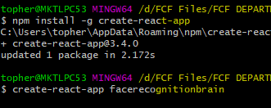Run “**create-react-app facerecognitionbrain**”
3. Create “components” and under of this is “Logo and Navigation” folder

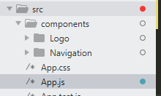

1. Install tachyons using this command “**npm tachyons**”
2. Install react tilt “**npm install –save react-tilt**”
3. Install react app interactive background <https://www.npmjs.com/package/react-particles-js>